**Tasks Day 2**

**Complete all exercises (send 1 summary screenshot). Using you bash console, execute:**

npx javascripting

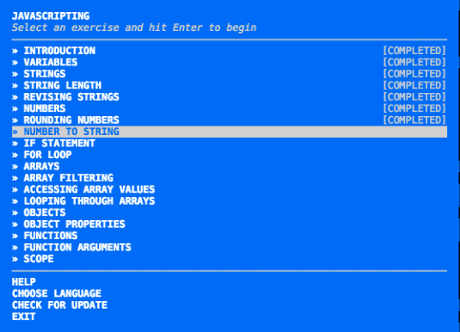

**Exercises Day 3**

**Learn the details of Scope, Scope Chains, Closures, and Garbage Collection, using:**

npx scope-chains-closures

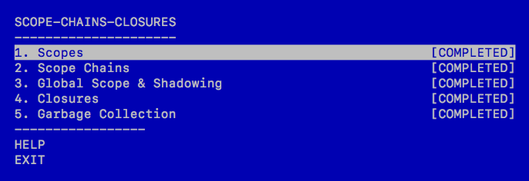

## Tasks Day 3

### Learn you how to use the terminal and write your first Bash script, using:

npx learnyoubash

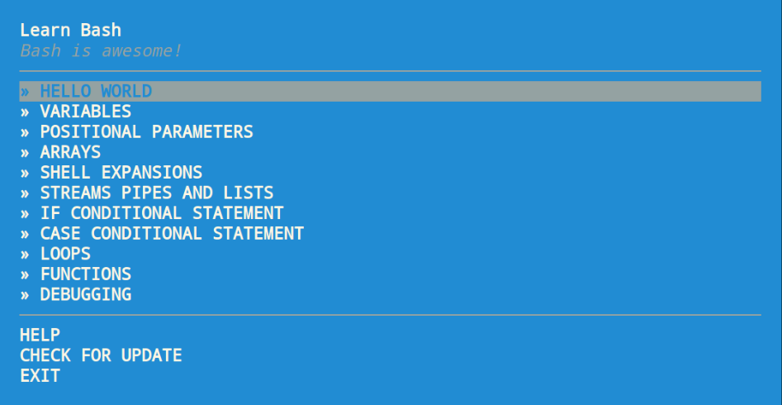

### Learn how to start using Markdown - a lightweight markup language with plain text formatting syntax, using:

npx how-to-markdown

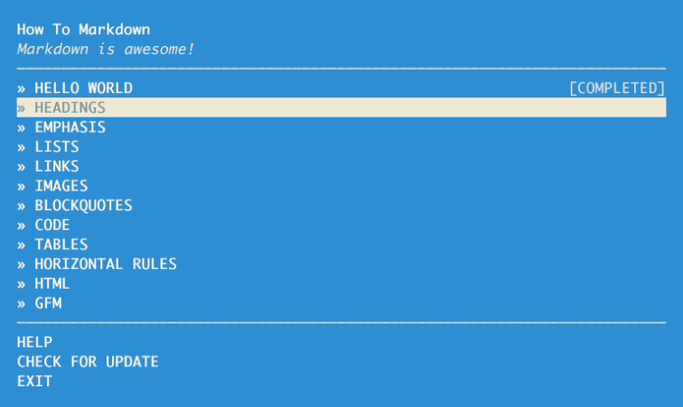

## Tasks Day 4

### Learn fundamental functional programming features of JavaScript in vanilla ES5., using:

npx functional-javascript-workshop

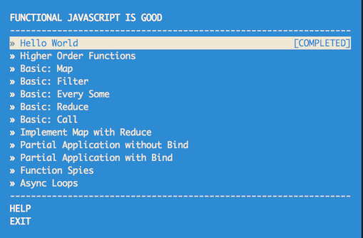

## Tasks Day

### Make a desktop application using Node and Chromium with Electron

npx elementary-electron

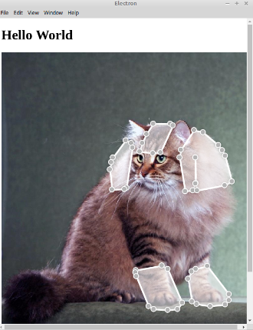

## Tasks Day 6

### Learn the basics of node: asynchronous i/o, http.

npx learnyounode

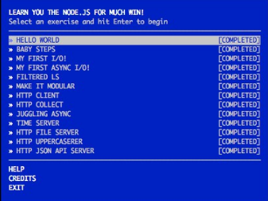

### Learn how to use some features from ES6, the next version of JavaScript.

npx count-to-6

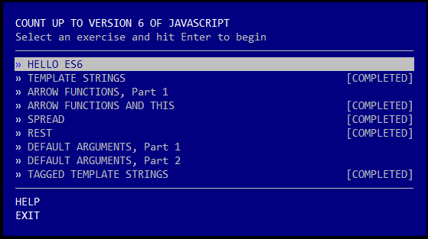

## Tasks Day 7

### Learn to use promises in JavaScript to handle async operations.

npx promise-it-wont-hurt

### Learn the basics of the Express.js framework.

npx expressworks

### Learn all about hapi through a series of challenges.

npx makemehapi

### Getting started with Koa, the next generation web framework for Node.js.

npx kick-off-koa

## Tasks Day 8

### Intro to ES6 Iterators, their use, and how they relate to Generators.

npx esnext-generation

### An Intro to JavaScript ES6 Generators.

npx learn-generators

### Understanding JavaScript Prototypes

npx planetproto

**Tasks Day 9**

**Show you through a series of exercises that introduce you to ES6 features.**

npx tower-of-babel

**Use npm modules and node-style require() in the browser with browserify.**

npx browserify-adventure

## Tasks Day 10

### Learn the basics of SASS.

npx learn-sass

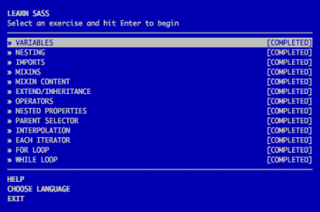

### Learn the fundamentals of the LESS/CSS preprocessor.

npx less-is-more

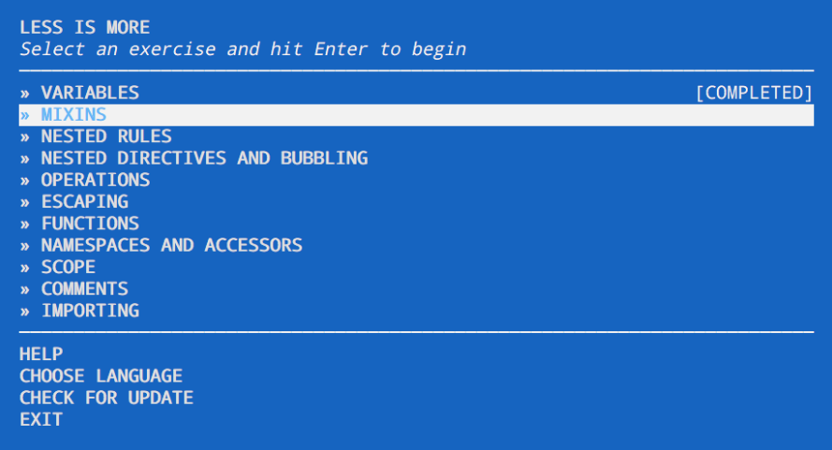

### Learn the best practices of writing clean Javascript code.

npx is-best-practices

